**Color palette:**

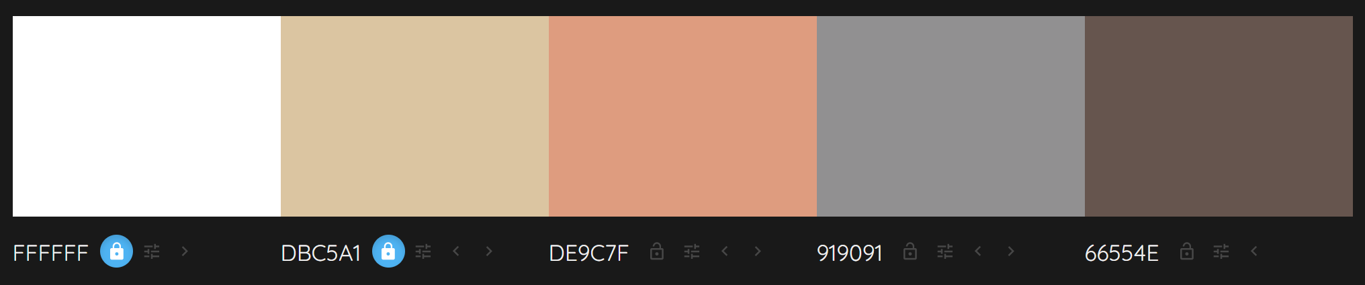

The original Duquesne Incline website used very bold shades of green and red in its color scheme. I thought the reddish color was important to maintain the brand, so I chose a reddish-orange and used a color palette generator to create the other colors that made up my website.

**Font Choice:**

My header font was Georgia, a serif font. I noted that we were only supposed to use serif fonts for short headings. The body of my text was Helvetic Neue, a sans-serif font. These fonts were based on the fonts we used in the labs because I felt like the two mixed well together.

**Layout Considerations:**

I tried to make my header unique by utilizing the white space that was originally there to put an image of the incline next to a pretty sky. Because of this, I chose to make the website span the entire page horizontally as it made the header image show up nicely.

I added a sidebar to display the most important information and to take up some space on the side so the webpage wouldn’t look so empty.

I tried to use horizontal lines to separate information that may differ that is put together on the same webpage, especially on the homepage and the About page.

For the bookings page, I used tabs to organize my information instead of putting it all on the page as I felt like tabs would reduce the visual clutter on the page.

**Design Considerations:**

I notice that the client cited in the correspondence that they wanted visitors to be able to easily navigate the site to learn about the Duquesne Incline. Also, the client says that visitors struggle to find important information such as hours of operation and other relevant information. Because of this detail, I thought the most important things to include would be the contact information and hours of operations, which is why they are in the sidebar, organized into tables. The other important information can be categorized into the four pages found on the navigation bar.

Although the client requested that photos be added to tables as well, I took some liberty on this issue to move the photos into a photo gallery on the homepage, because I felt like they would get more recognition there than piled into a table, which would also ruin formatting.

Another design choice I made for organization was on the Book a Trip page, where I employed the use of tabs to make information more accessible and less like an overwhelming amount of information rushing at the user of the website.

Another aesthetic design choice I made was to put a header at the top of the website featuring an image of the incline, as I thought it made the entire thing look livelier and more colorful, as it would otherwise leave a lot of white space across the website. However, this meant that I sacrificed the red and green color scheme of the original Duquesne Incline website, although I did try to keep as true to it as possible.

**Informational Architecture:**

I organized my content into four different pages which can be accessed through the navigation bar at the top of the page, as well as some additional information on the sidebar that can be seen through every page.

The sidebar contains some of the most important information about reaching the incline, which is why it is accessible on every page.

I decided that the Book a Trip information deserved its own page because there was a lot of information on pricing and fares within the content file we were given, and also because riding the incline is the main attraction of the website, which is why booking tickets is important enough to warrant its own section. Within the Book a Trip page, I separated them by type of trip so that users can quickly identify what category their trip falls under and look at the pricing and logistics from there.

I thought the About the Incline page deserved its own page as well. This was mostly because I thought these facts would clutter the home page, and it was not essential information that visitors of the Duquesne Incline needed to know before their visit.

Additionally, I made the mailing list form on a separate page as well, because I felt that the content was important enough that it should not be buried under other information on the homepage.

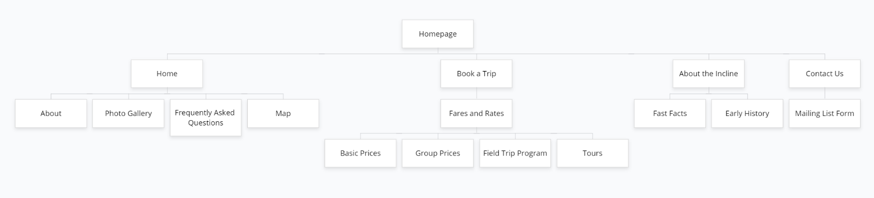Lastly, the homepage includes important information about planning a trip such as what exactly the incline is, pictures of the incline, frequently asked questions about the incline, and a map of where to find the incline. All of this information is important when planning a visit, which is why I placed it on the homepage.